Where the Future of Smart Manufacturing Takes Shape: ITW Asia 2025 Opens in Shenzhen

(28 October 2025, Shenzhen) – ITW Asia 2025 – Industrial Technology World Asia officially opened on October 28 at the Shenzhen World Exhibition & Convention Center (Bao’an), launching a dynamic three-day exploration of industrial innovations.

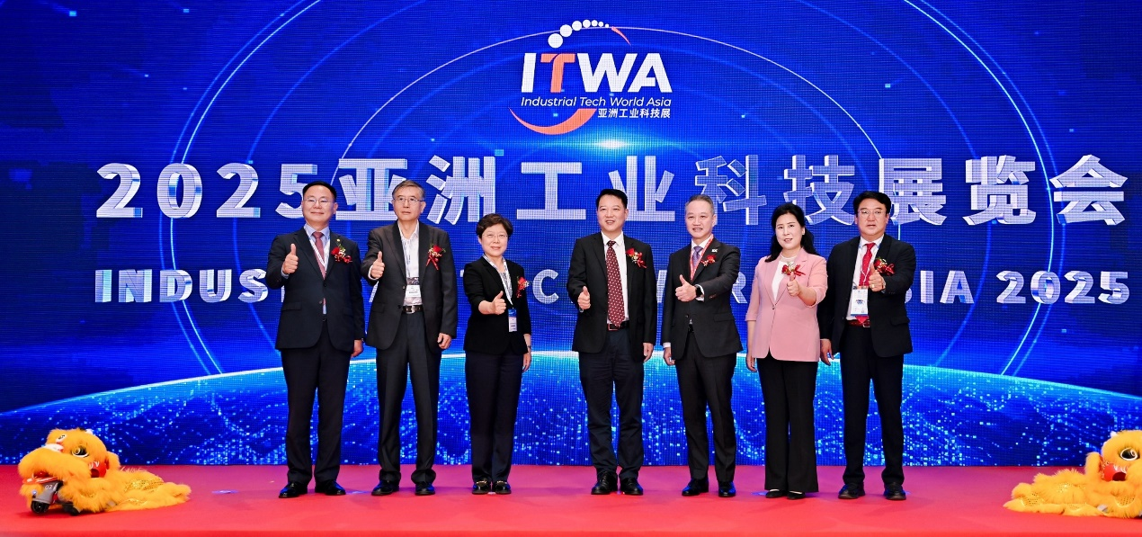

The opening ceremony drew close to 100 distinguished leaders and guests from the China Council for the Promotion of International Trade, industry associations, Shenzhen municipal government, exhibiting companies, overseas partners and media. Together, they marked this important industry milestone. This year’s ITW Asia places a strong emphasis on the integration of “AI + Industry” with robotics taking the center stage. A captivating robotic dance performance at the opening ceremony demonstrated both technological sophistication and entertainment, underscoring ITW Asia’s role in linking Shenzhen to the global technology stage.

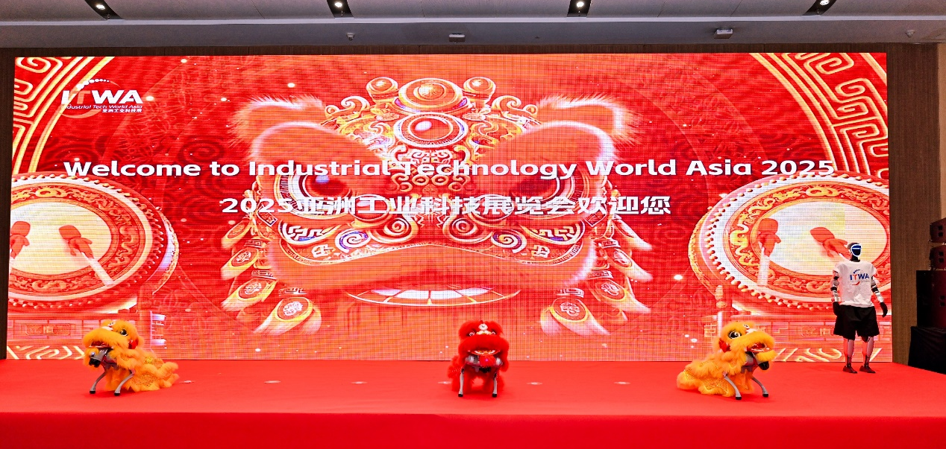

Under the theme “Where Industries Connect, The Future is Made”, ITW Asia 2025 unites 8 flagship exhibitions, creating a deeply integrated showcase of cutting-edge technologies and innovations across four key advanced manufacturing sectors: automotive, electronics, displays, and new materials. These co-located shows include Vision China Shenzhen, S-Factory, NEPCON ASIA, Electronics Sourcing Show, Automotive World China, C-TOUCH & DISPLAY SHENZHEN, COMMERCIAL DISPLAY, and FILM & TAPE EXPO.
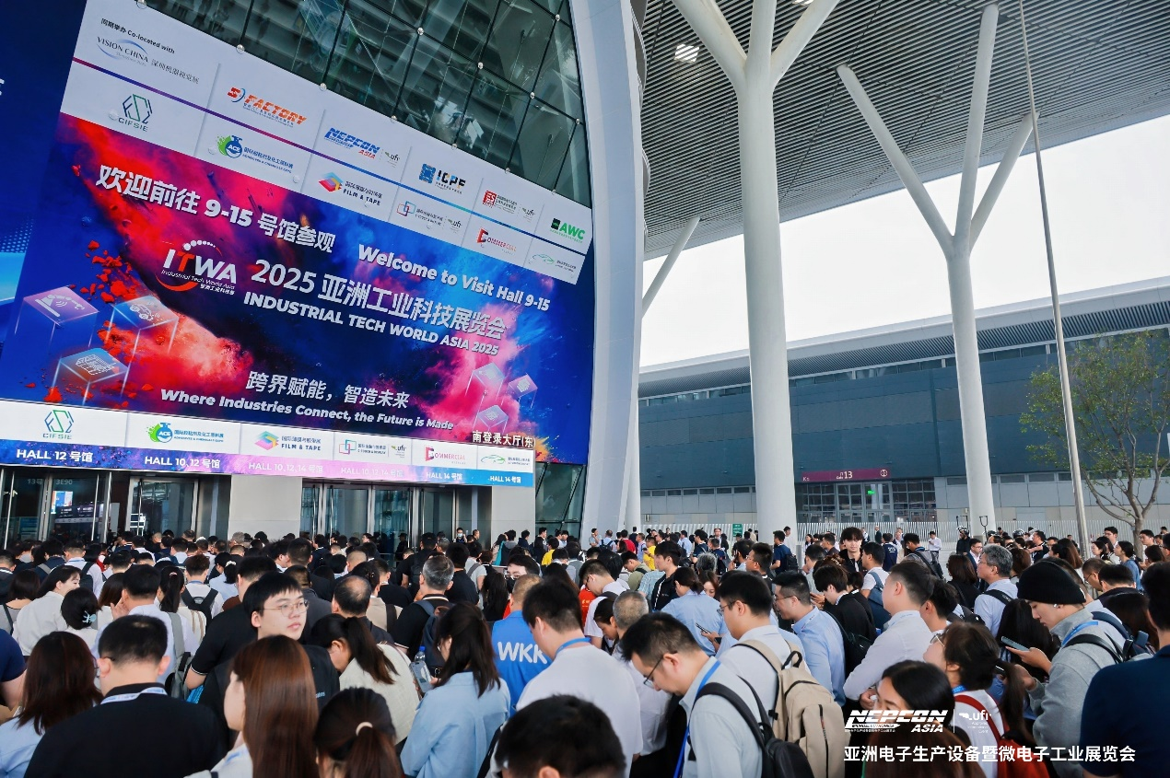

Global Momentum: Shaping the Innovation Landscape
Shenzhen, renowned as "China's Industrial Capital" and a global innovation hub, provides ITW Asia 2025 with an ideal ecosystem, combining a solid industrial foundation with concentrated innovation resources. This makes the mega event a premier platform for debuting and validating next-generation manufacturing technologies. This year’s event is the stage for numerous global and China-first product launches, while the synergy of its 8 flagship exhibitions amplifies its impact.

A powerful lineup of over 3,500 Chinese and international exhibitors is presenting their latest solutions, featuring industry leaders such as Baumer, Daheng-imavision, SmartMore, Do3think, BOE, TCL CSOT HKC, iFLYTEK, FANUC, Fuji, 3M, Han’s Laser, Hanwha, Yamaha, E-Ink, Caihong Group, CSG, Flexiv, Elibot, Neolix, Rino.ai, AUTO CITY, National Intelligent Voice Innovation Center, DKE, Agilebot, Jingbei, , Masonsemi, Sinhoo, Trulyopto, WG Tech, Tesa, Crown, Youyi Tape, YG Group and many more. A dedicated International Pavilion brings together over a hundred renowned companies from Japan, South Korea and Europe, offering a strategic vantage point for gaining insights into global technology trends.

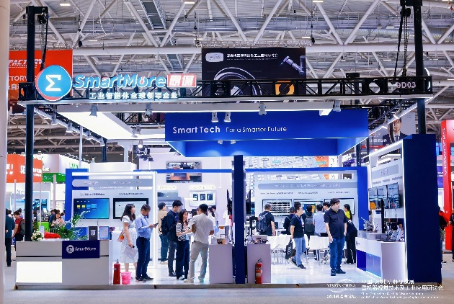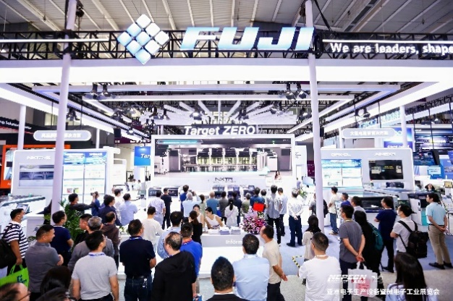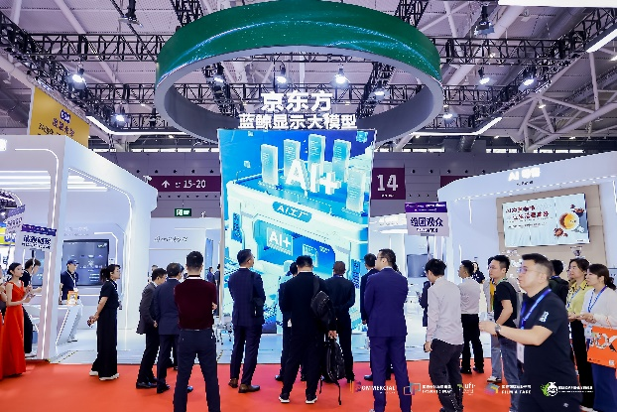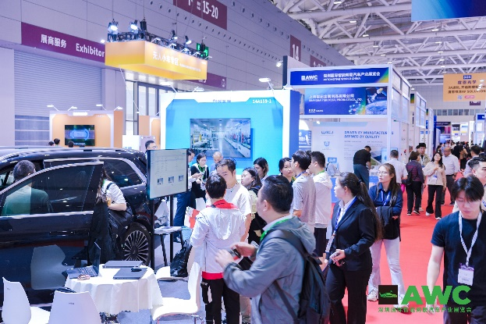

Vision for the Future: Decoding Industrial Transformation Pathways
Beyond the comprehensive exhibition, ITW Asia 2025 employs a multi-dimensional approach—combining trend releases, specialized zones, and forum dialogues—to deliver deep insights into technological evolution and market directions, offering actionable strategies for industrial upgrading. Nearly 20 themed zones highlight diverse innovations and application integrations. From the Machine Vision Innovation Product Exhibition Area and New Energy Electronics Area to the Embodied Intelligence Robot Core Parts Disassembly Area, UNMANNED VEHICLE Zone, and AI+AR Smart Glass Experience Zone, the event offers a holistic view of the technologies shaping tomorrow’s industries.

The intellectual core of ITW Asia 2025 is formed by over 80 high-caliber forums and seminars, serving as a vital hub for professional exchange and knowledge sharing. On the opening day, a series of well-attended forums took place, including the VISION+AI Empowering Electronics Manufacturing Seminar, Tailored Intelligent Robot Manufacturing Technology Salon, AI-Driven Smart Factory and Automation Innovation Forum, New Energy Electronics and Future Industry Forum, AWC Automotive Industry Technology Forum, The 28th International New Display and Touchscreen Elite Summit, The 6th International Film and Tape Technology Innovative Development Forum, and AI Roadshows. These sessions provided participants with valuable insights and fresh ideas, earning high praise for their content quality and industry relevance.
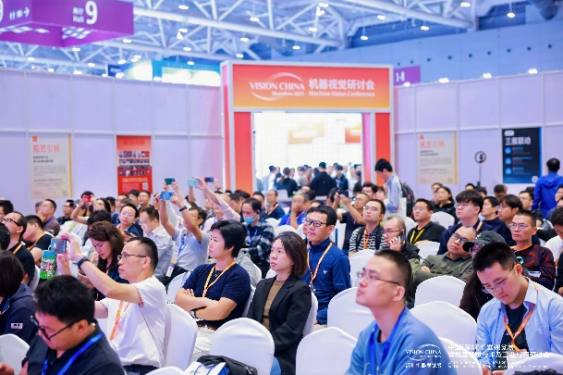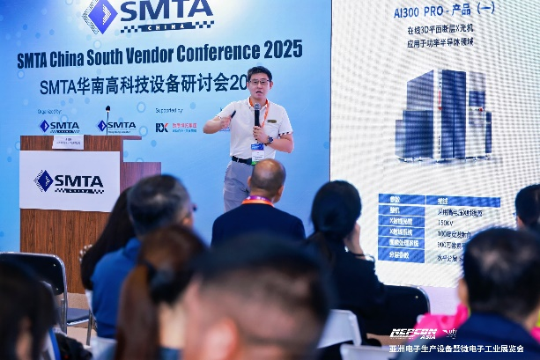
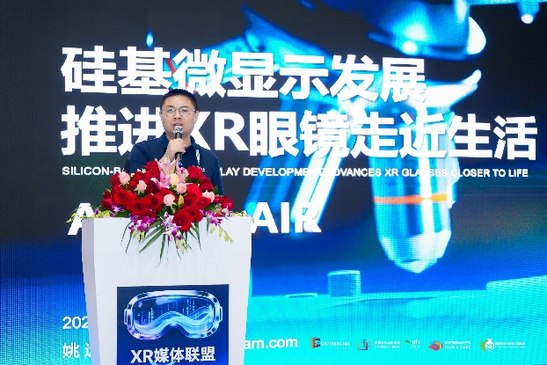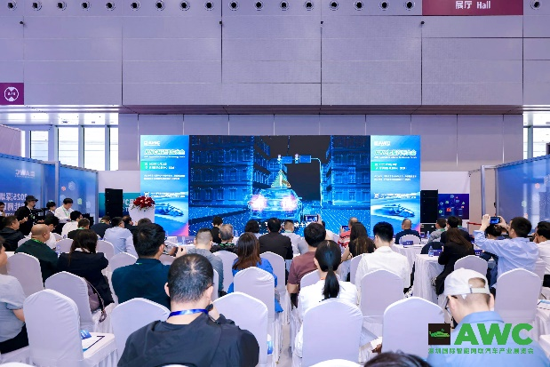

Global Collaboration: Reshaping Industrial Value Chain
ITW Asia 2025 acts as a central hub connecting global manufacturing forces, addressing business needs for new partnerships through targeted business matchmaking services. The event is projected to welcome more than 160,000 visitors, including 5,000 international attendees from 150 countries and regions, alongside 800 professional visiting groups. Attendees source new products, connect with upstream and downstream resources, and explore opportunities for international trade and collaborative innovation.

The “International Tech Salon” showcases cutting-edge electronic manufacturing through live demos and case studies for international visitors. Selected international buyers are also invited on factory tours to leading companies such as Suneast and Risong Technology to witness the dynamism of advanced manufacturing firsthand. Furthermore, the “UK-Shenzhen Innovation Workshop,” organized by the UK Department for International Trade and London Development Agency, will focus on AI, digital energy, and IoT, helping Chinese enterprises understand UK industrial strategies and fostering dialogue for long-term global collaboration.

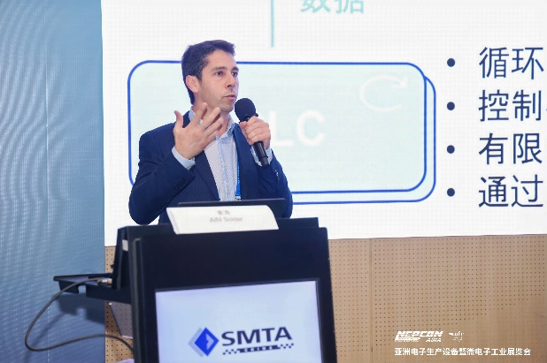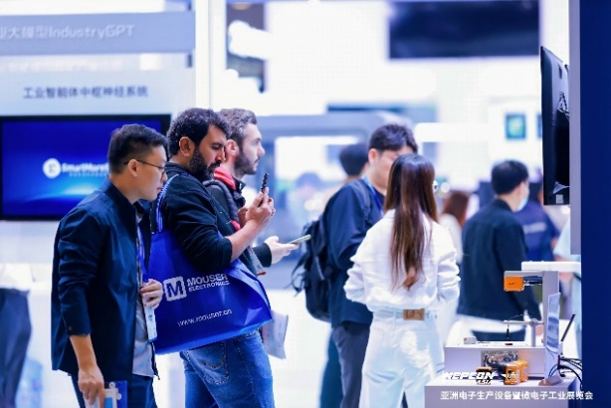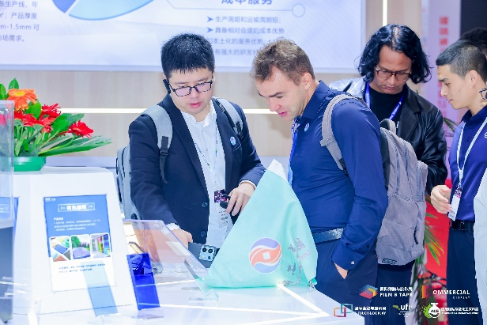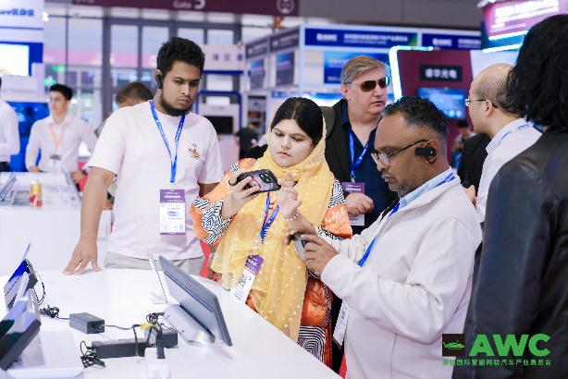

Enhanced Digital Services: RX Connect Empowers Efficient Participation
To help attendees maximize their time, ITW Asia 2025 has upgraded RX Connect, a handy mobile tool for all participants. Key features include Online CS, offering 24/7 bilingual support for visitor inquiries, and Colleqt, which enables users to digitally collect exhibitor information. RX Connect also supports advanced exhibitor search and information management, helping visitors navigate the exhibition more efficiently and precisely.


Access Eight Exhibitions with One Badge
From 28-30 October at the Shenzhen World Exhibition & Convention Center (Bao’an), industry professionals are invited to immerse themselves in ITW Asia 2025—gaining insights, discovering innovations, and contributing to the advancement of the global advanced manufacturing value chain.

Visitor Registration
https://ali2.infosalons.com.cn/reg/NEPCON25FORM/web/MEGASHOW25VST/?sessionid=#/login?lang=zh-CN

###

About ITW Asia 2025
Industrial Technology World Asia ( ITW Asia 2025) is one of Asia’s leading industrial technology trade shows, dedicated to promoting cross-industry technological integration and industrial upgrading. This year, in strategic partnership with RX and the CMVU, the event features eight flagship industry exhibitions, covering machine vision, advanced electronics manufacturing, new energy vehicles, emerging displays, and new materials. ITW Asia 2025 is a crucial platform for international trade, technology innovation, and global industry networking, helping enterprises capture market opportunities and expand global collaborations.

Contact Information

Visitor & Delegation Inquiries
- Mr. Walden Li | E: walden.li@rxglobal.com | WhatsApp: +86 136 51251335
- Mr. Sam Jia | E: sam.jia@rxglobal.com | WhatsApp: +86 13601261540
Exhibitor Inquiries
- Ms. Grace Zhang | Tel: +86 21 2231 7027 | Email: grace.zhang@rxglobal.com
Buyer & Business Matchmaking
- Mr. Alan Lee | Tel: +86 21 2231 7155 | Email: alan.lee@rxglobal.com
Media & Partnership Inquiries
- Ms. Caroline Ye | Tel: +86 755 2383 4565 | Email: caroline.ye@rxglobal.com
- Ms. Annie Li | Tel: +86 21 2231 7072 | Email: annie.li@rxglobal.com

